1. Take your new MicroSD card

2. Insert it into a microSD card reader, and put it into a Windows computer.

3. You should get the following message. DO NOT CLICK FORMAT. Click cancel

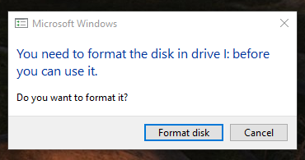

4. Launch Win32 Disk Imager

5. Once Win32 Disk Imager launches, you should see this screen:

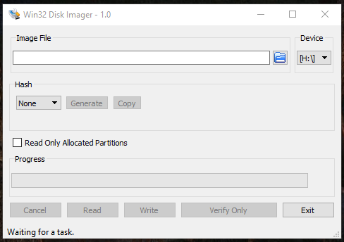

6. Click the little blue folder icon and browse to the image you made of the Raspberry Pi’s MicroSD card.

7. MAKE SURE THE DRIVE LETTER LISTED UNDER DEVICE IS YOUR MICROSD READER

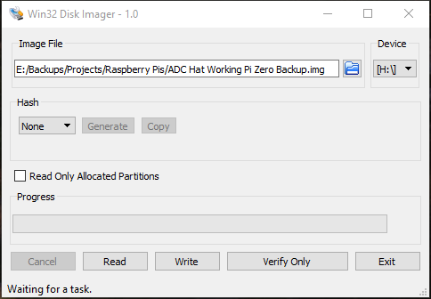

8. Press “Write” you should see:

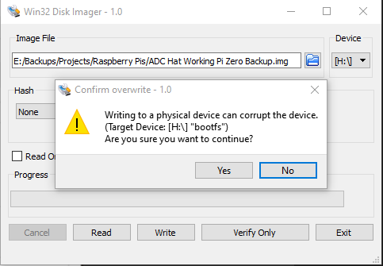

9. Press yes. This basically just means “Don’t turn off your PC in the middle of writing and you’ll be fine.”

10. You’ll see it write the image to the SD card, with a time remaining in the bottom right

11. When finished, you should see this message:

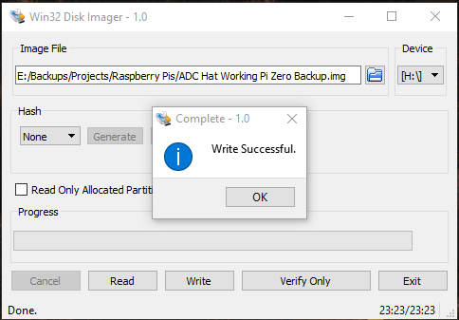

12. Press Ok, then exit

13. IMPORTANT: Click on the “Safely Remove Hardware” icon by the clock, and eject your MicroSD reader

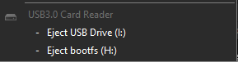

A terrible fate will certainly befall you should you not adhere to my words of wisdom…

(Just do it, please)

At this point, you can put the MicroSD card back into the Pi and fire it up!

